

**NGO SUSTAINABILITY**

GLOBAL WARNING +1.2°C

*LATEST NEWS IN SUSTAINABILITY*

*NO. 147 | January 2024*

PROMOTING SUSTAINABLE LIVING AND RENEWABLE ENERGY FOR THE FUTURE OF OUR PLANET

[ngosustainability@gmail.com](mailto:ngosustainability@gmail.com) | [unngosustainability.org](https://www.unngosustainability.org)

Consultative Status, the United Nations Economic and Social Council (ECOSOC)

Observer Status, United Nations Environment Programme (UNEP)

*Your comments are always welcome.*

*Please feel free to reproduce and share with your colleagues.*

*- NGO Sustainability team*

***“The debate has too often centered on how likely various doom-and-gloom scenarios are, and when they’ll occur. But scaring people doesn't work." -Michael Bloomberg, Former Mayor of New York City, UN Special Envoy on Climate Ambition and Solutions***

**Michael Bloomberg**

Michael R. Bloomberg, a global leader in business and climate change advocacy, serves as the UN Secretary-General’s Special Envoy on Climate Ambition and Solutions. Bloomberg’s former tenure as Mayor of New York City, was marked by a notable reduction in carbon emissions and an increase in life expectancy, reflecting his commitment to sustainable urban policies. Notably as mayor, Bloomberg launched his Million Trees NYC initiative, successfully planting and caring for one million new trees across the boroughs. In his role as UN Special Envoy, Bloomberg mobilizes ambitious climate action, targeting high-emitting countries and industries to accelerate the clean energy transition. He plays a pivotal role in global initiatives like the phase-out of 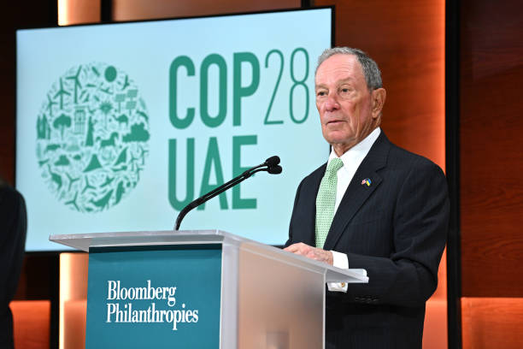  
Bloomberg Announcing COP28 Local Climate Action Summit, 2023  
coal and the promotion of renewable energy, underlining his commitment to the Paris Agreement’s goals. Bloomberg also supports local climate actions through his leadership in networks such as the C40 Cities Climate Leadership Group and the Global Covenant of Mayors for Climate & Energy. Bloomberg’s influence extends to the financial sector, where he chairs the Task Force on Climate-related Financial Disclosures, enhancing transparency in climate-related risks and opportunities.

# **Excerpt from “Earthrise”**

# **by Amanda Goreman [1]**

# Where despite disparities We all care to protect this world, This riddled blue marble, this little true marvel To muster the verve and the nerve To see how we can serve Our planet. You don’t need to be a politician To make it your mission to conserve, to protect, To preserve that one and only home That is ours, To use your unique power To give next generations the planet they deserve.

# We are demonstrating, creating, advocating We heed this inconvenient truth, because we need to be anything but lenient With the future of our youth.

# And while this is a training, in sustaining the future of our planet, There is no rehearsal. The time is Now Now Now, Because the reversal of harm, And protection of a future so universal Should be anything but controversial.

# So, earth, pale blue dot We will fail you not.

**“2023 Was the World’s Warmest Year on Record, By Far”**

By: *NOAA  
*

*Photo: Getty Images*

The National Oceanic and Atmospheric Administration (NOAA) reported that 2023 was the warmest year on record, surpassing the previous record set in 2016. This conclusion is based on an analysis by NOAA's National Centers for Environmental Information. The year’s average land and ocean surface temperature was 1.18 degrees Celsius above the 20th-century average, the highest in NOAA's 1850-2023 climate record. Notably, the ten warmest years since 1850 have all occurred in the past decade, with 2023’s average temperature surpassing the pre-industrial average by 1.35 degrees Celsius. Additionally, there is a significant probability that 2024 will be even warmer than 2023. The report also highlights that global ocean heat content reached a new record high in 2023, with the upper 2,000 meters of the ocean storing more heat than ever recorded. This is significant as the ocean absorbs 90% of the Earth's excess heat. Furthermore, both Arctic and Antarctic sea ice extents were among the lowest on record in 2023, reflecting the continued impact of climate change. The findings underscore the urgency of addressing climate change and its impacts, including the increase in frequency and severity of extreme weather events.  
 [Full Article](https://www.noaa.gov/news/2023-was-worlds-warmest-year-on-record-by-far) **“France implements compulsory composting. Here’s how it will help slash emissions”**

By:Angela Symons, *Euro News*



*Photo:* *Getty Images*As of January 1, 2024, the separation of organic waste has been mandatory in France. Although there will be no fines for non-compliance the new rule aims to reduce organic waste, which accounts for one-third of the total household waste and accounts for 8% of the total man-made emissions, according to the UN. By recycling food scraps, biogas and compost will be created to replace chemical fertilizers. This initiative by France is part of a broader, pan-European movement towards establishing a more sustainable food chain. Several European countries have already adopted similar measures, reflecting a growing recognition of the need to integrate sustainability into waste management practices. The policy aligns with global environmental goals and contributes to the collective effort in combating climate change and promoting ecological balance.chart a more sustainable course for the massive shipping industry critical to world trade.

[Full Article](https://www.euronews.com/green/2024/01/02/france-implements-compulsory-composting-heres-how-it-will-help-slash-emissions)

**“Massachusetts Switches On Its First Large Offshore Wind Farm”**

By: Brad Plumer,  *New York Times*

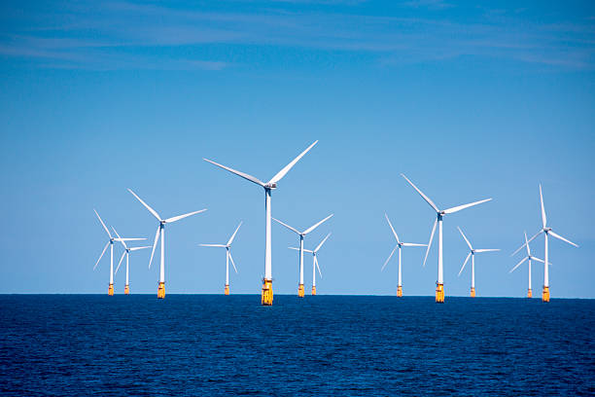

*Photo: Getty Images*

The first large offshore wind farm in New England, Vineyard Wind, has started generating

electricity off the coast of Massachusetts. This marks a major milestone for the emerging US

offshore wind industry, which has faced recent headwinds like rising costs and project

cancellations. Vineyard Wind has initially switched on just one turbine out of a planned 62,

capable of powering 400,000 homes at 800 megawatts total capacity. It comes online as the

second major US offshore wind project after New York's South Fork Wind began operating in December 2023. However, numerous other planned projects have been scrapped lately due to supply chain woes, inflation, higher interest rates, and local opposition making profits uncertain. Forecasts for 2030 US offshore wind deployment are now down by two-thirds. Even approved projects are proving more expensive than states initially counted on. Offshore wind is seen as crucial for Northeast states to reduce greenhouse gas emissions from electricity. But after early political tailwinds, the realization phase is proving rocky. Vineyard Wind's launch is thus considered a watershed marker of progress for offshore wind.

[Full Article](https://www.nytimes.com/2024/01/04/climate/vineyard-wind-massachusetts.html)

**“**“**Puerto Rico Is Harnessing Home Solar Rigs to Stabilize Its Power Grid”**

By: Gabriela Aoun Angueira, *Mother Jones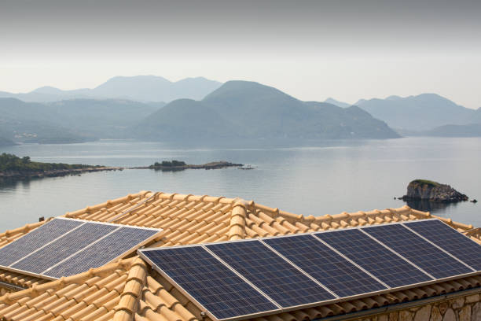*

*Photo: Getty Images*

To create backup power for its electrical grid, Puerto Rico has started to use batteries connected to people’s rooftop solar panels. During the pilot program that began recently, the territory’s utility Luma Energy will derive power from up to 6,500 households and it could provide 26 megawatts of power. The compensation for customers is $1.25 per kilowatt-hour. The goal is to create a larger virtual power plant and possible peaker plants that operate during shortages. Virtual power plants (VPP) use a network to aid the grid, sourcing energy from heat pumps, electric water heaters, home batteries and the like. The operation of the VPP could save the US $10 billion by avoiding the use of peaker plants or the need to create additional infrastructure. There is a growing trend for solar in Puerto Rico, where 100,000 households have rooftop solar and 4,000 units are established each month.

[Full Article](https://www.motherjones.com/politics/2024/01/puerto-rico-residental-solar-batteries-power-grid/)  **“California Pushes Electric Trucks as the Future of Freight”**

By:Peter Eavis, *New York Times*

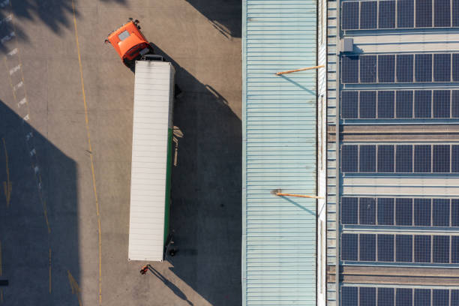

*Photo: Getty Images*

California is pushing aggressively to phase out diesel-powered freight trucks and replace them

with electric models, starting with a ban on new registrations of carbon-fuel trucks at ports

beginning in 2023. The goal is to completely transition port freight to zero-emissions vehicles by 2035, seen as a crucial step towards broader economy-wide decarbonization. However, the

switchover faces enormous hurdles like high EV costs and a lack of charging infrastructure.

Smaller fleets handling 70% of port freight worry they can't afford the changeover. Larger firms like Maersk are farther along, with dozens of electric rigs. Financial aid and leasing help some, but gaps remain in charging capability. Neighboring communities stand to gain from lower pollution, but residents already suffer health issues from current heavy port traffic. The rules have drawn lawsuits from trucker groups over economic feasibility. Proponents argue short-term impacts are outweighed by environmental and health gains. They see progress if production volumes, reliability and charging access rise fast enough to support 100% EV port freight over the phase-in period. Success could provide a model for national efforts.

[Full Article](https://www.nytimes.com/2023/12/28/business/energy-environment/electric-trucks-port-california.html)

**“Study: Flowers are Starting to Self-Pollinate Due to Fewer Insects?”**

By: Phoebe Weston, *Mother Jones*



*Photo: Getty Images*

Flowers have naturally evolved to be attractive to pollinators so that their future generations will grow. However, researchers have seen flowers “giving up” on pollinators and growing to be less attractive as insect numbers are reduced. A finding showed that pansy fields near Paris are producing ⅕ less nectar than flowers in the same area two to three decades prior. The flowers’ strategy to self-pollinate and reproduce with itself is helpful in the short term but may inhibit their adaptive capability to climate change. The method of study involved “resurrection ecology” where seeds were grown from storage in national botanical conservatories. This trend is a result of thousands of years of evolution undoing itself for a human induced occurrence only around in the past few decades.

[Full Article](https://www.motherjones.com/environment/2023/12/study-flowers-are-starting-to-self-pollinate-due-to-fewer-insects/)

**“More than 10 million new trees: award-winning plan to reforest the Andes”**

By: Iván Antezana Q & Flor Ruiz, *El País*



*Photo: Getty Images*Since 2018 ‘Acción Andina’ has planted 10 million trees, rehabilitated 4.000 hectares of the Andes forests, and conserved 11.000 hectares of native forests to fight against deforestation in the Andes Mountains. Acción Andina's focused reforestation strategy involves the Polylepis species, an endemic shrub and tree species uniquely adapted to the high-altitude conditions of the Andean Cordillera. The Polylepis is not just a symbol of the Andean landscape but also plays a crucial ecological role. By replanting these species, the initiative enhances the region's capacity for carbon dioxide absorption and water regulation. This is important in the context of climate change, as these trees can sequester significant amounts of CO2 while maintaining the hydrological cycles vital to both the Andes and the communities that depend on them. The organization has received the EarthShot award for its efforts and with the prize money has the opportunity to reach its goal of planting 100 million trees by 2045.

[Full Article](https://elpais.com/america-futura/2024-01-11/mas-de-10-millones-de-arboles-nuevos-el-premiado-plan-que-reforesta-los-andes.html) **“Canada’s Logging Industry Devours Forests Crucial to Fighting Climate Change”**

By:Ian Austen and Vjosa Isai, *New York Times*

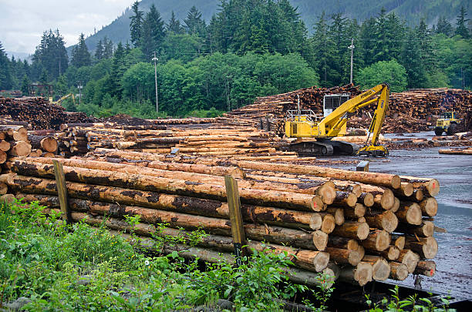

*Photo:* *Getty Images*

A new study by researchers at Australia’s Griffith University suggests that tree logging in the Canadian provinces of Ontario and Quebec has caused severe damage which will be difficult to reverse to the boreal forest. According to the study, 35.4 million acres (roughly the size of New York state) of such forest has been removed since 1976. Collectively, the world’s boreal forests hold 703 gigatons of carbon dioxide. The landscape that remains after logging not only holds much less carbon, but is also less able to support wildlife. Ecologically speaking, forest degradation is thus a greater threat than the actual removal of trees, as is often the case in other parts of the world. The findings are at odds with Canada’s stated commitments to protect its vast natural resources. According to Peter Wood, a lecturer on forest resources management at the University of British Columbia, “Canada has downplayed the impact of the forest industry.”

[Full Article](https://www.nytimes.com/2024/01/04/world/canada/canada-boreal-forest-logging.html?smid=nytcore-ios-share&referringSource=articleShare)

*Plastic Packaging & Waste Policies: Sweden vs Spain*

*By: NGO Sustainability Intern, Paula Grandas*

Recycling measures and effective waste management are crucial for fostering an eco-friendly circular economy. In Europe, approximately 26 million tonnes of plastic waste are generated annually. The European Union's 2020 Circular Economy Action Plan (CEAP) includes a plastic packaging policy with targets of recycling 50% by weight of plastic packaging waste by 2025 and 55% by 2030. To achieve these objectives, Member States are enacting domestic laws that comply with European standards. This report compares the national strategies of Sweden and Spain, providing a comparative analysis in the area of plastic packaging policy.

In 2021, Spain enacted the Waste and Contaminated Soil Law, incorporating the European directive on single-use plastics from 2019. This law mandates a 50% reduction in single-use cups and containers for immediate consumption by 2026, and 70% by 2030, relative to 2022 levels. It also requires free tap water in restaurants, aims for a 70% selective collection rate of plastic beverage bottles by 2023, increasing incrementally to 90% by 2029, and mandates organic waste separation in municipalities with over 5,000 inhabitants, using compostable bags.

Sweden launched a national action plan for plastics in February 2022, supplementing existing measures such as free water in restaurants and a deposit return system for beverage bottles and cans. The Swedish government aims for an average annual usage of 40 plastic bags per person by 2025 and a minimum of 30% recycled material in plastic packaging by 2045. In contrast, Spain imposes a limited packaging tax of 0.45 EUR/kg on non-recyclable plastics in non-reusable packaging. Both countries have set a goal of reducing the consumption of single-use plastic cups and food containers by 50% by 2026. Additionally, Sweden implemented a measure in January 2024 prohibiting disposable cups containing over 15% plastic. However, Sweden is considering abolishing a 0.25 EUR tax on plastic carrier bags, compared to Spain's 0.05 EUR tax.

Despite Spain's new plastic legislation, it faces challenges compared to Sweden. According to 2022 European Environment Agency reports, Spain is at risk of not meeting its plastic packaging waste recycling targets, unlike Sweden. Spain's plastic capture rate is 20%, while Sweden's is 29%. However, Spain has a higher proportion of the population with access to convenient collection services, whereas Sweden has a medium share, with urban areas lacking proper collection methods. Spain's failure to meet targets is partly due to non-compliance with regulations, such as offering free water in restaurants. In contrast, Sweden widely provides free water in public places. Additionally, Spain is yet to implement a PET bottle return system, which is already in place in supermarkets in Sweden.

Both Sweden and Spain, as members of the European Union, are committed to achieving the goals of the European Green Deal, including recycling 50% of plastic packaging by 2026 and 55% by 2030. While both countries are pursuing national strategies tailored to their population's circumstances, they share the common objective of fostering a greener economy and a greener Europe. However, both nations must continue to make progress to ensure the fulfillment of these goals.

1. Cerrillo Barcelona, A. (2021). The 15 keys to the waste law, with which Spain seeks to meet the requirements of the EU. Retrieved from La Vanguardia: https://www.lavanguardia.com/natural/20211223/7950133/15-claves-ley-empieza-desterrar-plasticos.html
2. EUR-lex. (2020). Packaging and packaging waste. Retrieved from EUR-lex: https://eur-lex.europa.eu/legal-content/EN/TXT/?uri=LEGISSUM:l21207
3. European Environment Agency. (2022). Early warning assessment related to the 2025 targets: Spain.
4. European Environment Agency. (2022). Early warning assessment related to the 2025 targets: Sweden.
5. Milios, L., Esmailzadeh Davani, & Yu, Y. (2018). Sustainability Impact Assessment of Increased Plastic Recycling and Future Pathways of Plastic Waste Management in Sweden. MDPI. Retrieved from https://doi.org/10.3390/recycling3030033
6. United Nations. (n.d.). Sweden commits to reduction of plastic pollution by adopting a National Plastic Action plan with goals and concrete actions. Retrieved from United Nations:https://sdgs.un.org/partnerships/sweden-commits-reduction-plastic-pollution-adopting-national-plastic-action-plan-goals

*Reaching COP 28 Action Goals: Enabling Sustainable Transitions*

**Background**COP 28 - the 28th meeting of the Conference of Parties of the UN Framework Convention on Climate Change (UNFCCC) was held in Dubai, United Arab Emirates, from November 30 to December 12, 2023, under the leadership of Sultan al-Jaber of the UAE. It was the biggest climate change conference convened to date, held under the theme of “Together for Implementation”.

It was anticipated that significant progress would be made on tackling the global challenges of climate change, including the phase-out of fossil fuels to meet commitments of the Paris Agreement of 2015 towards staying within 1.5 degrees C (2.7 degrees F) above pre-industrial levels. Noteworthy was that the meeting took place in the hottest year in recorded history, and came on the heels of the COVID-19 pandemic which has resulted in considerable setbacks in progress on meeting climate commitments.

**Outcomes**

1) A climate loss and damage fund was set up in 2022 at the COP 27 meeting held in Egypt, and was operationalized at COP 28. The Fund will be administered by the World Bank. Global leaders ratified the plan to compensate the world’s most vulnerable countries for the irreversible losses caused by climate change. They pledged nearly $800 million to the fund. It is estimated that climate -related damages could cost developing countries between $280-$580 billion annually by 2030.

2) COP 28 undertook the first Global Stocktake following the Paris Agreement, and recognized the need for countries to make significant, rapid and sustained reductions in greenhouse gas emissions to meet the 1.5 degrees C target. This resulted in an agreement to transition away from fossil fuels. The final agreement stated that countries will “contribute ...to transitioning away from fossil fuels in energy systems in a just, orderly and equitable manner...so as to achieve net zero by 2050 in keeping with the science”.

This was a historic move. It did not however call explicitly for the phase-out of fossil fuels, which many governments had wanted. Small island states, especially hard hit by rising seas and climate change, expressed disappointment in this regard.

Many developing countries also expressed dismay that adequate financing was not secured for countries to make the transition from fossil fuels to green energy.  
  
The call to transition away from fossil fuels was made specifically for energy systems. OPEC countries (who control up to 80% of global oil reserves and roughly a third of the global output of oil) had wanted the emphasis to be on emissions reductions as opposed to transitioning away from fossil fuels. Their governments are heavily reliant on revenues which accrue from oil.

3) Countries agreed to contribute to global efforts to triple renewable energy capacity and to double the global annual average rate of energy efficiency improvements by 2030, and to speed up efforts to reduce the use of unabated coal power. This builds on the recent agreement on coal signed by the US and China - the world’s two largest emitters.

4) Countries agreed to intensify their efforts towards net zero emission systems, including accelerating the use of zero - and low-emission technologies, and to using zero-and low-carbon fossil fuels (natural gas) by the middle of the century. They are required to submit stronger carbon cutting plans by 2025.

While the deal also called for accelerated efforts to reduce non carbon-dioxide emissions, including methane emissions by 2030, it made provision for the continued use of transitional fuels and gave support for the use of carbon capture and storage, considered by some to be expensive and unproven at scale.

5) Other outcomes included a call to rapidly reduce emissions from road transport (including through accelerating deployment of zero and low emission vehicles).

Also of significance was the adoption of the Global Goal on Adaptation (GGA) framework established under the Paris Agreement, and calls for better aligning of finance flows with GHG emissions reductions and climate resiliency.

**Way Forward**Only six years are left to reach the target of reducing greenhouse gas emissions by 45%. Despite shortcomings, the agreement to transition away from fossil fuels is regarded as the biggest step forward since the Paris agreement was signed in 2015.

As the cost of renewables continues to fall, it is anticipated that increased pressure to

phase-out fossil fuels will result. It is hoped that the next two COP meetings to be held in Azerbaijan and Brazil in 2024 and 2025 respectively, will make more progress in this regard.

The significance of the COP 28 outcome document will depend on its implementation. Member states, the private sector and civil society will be responsible for delivering through their national policies and investments. Industrialized countries will need to take the lead, bearing the brunt of the responsibility historically for climate change. The US (the world’s top producer of oil and gas, and the largest emitter of greenhouse gases), along with countries like China and India need to accelerate efforts to transition away from fossil fuels.

Despite worldwide efforts to reduce emissions, oil, gas and coal still account for 80 % of the world’s energy. Rich countries need to do more to help finance the energy transition away from fossil fuels in developing countries.

Notwithstanding the gaps, loopholes and weaknesses in the COP 28 deal, the meeting could be regarded as a win for multilateralism. Important opportunities now to address broader sustainability issues and to show-case how economic and environmental goals can intersect and align towards achieving the ultimate goal of carbon neutrality.

NGO Sustainability is playing a role in helping to support and highlight initiatives which are underway, and in disseminating information on lessons learned in the context of sustainable development.

We look forward to continued involvement in projects in the developing world.

Producer: Roma Stibravy, President

Editor: Catie Eiref - Columbia University Mailman School of Public Health

Contributors: NGO Sustainability Interns

**BECOME A MEMBER OF NGO SUSTAINABILITY!**

**SEE CORPORATE SPONSORSHIP OPPORTUNITIES**

[unngosustainability.org](http://unngosustainability.org)

1. Amanda Goreman. "Earthrise", 2021.